Practical-6
Task-1
Compilation and Execution:
Client:
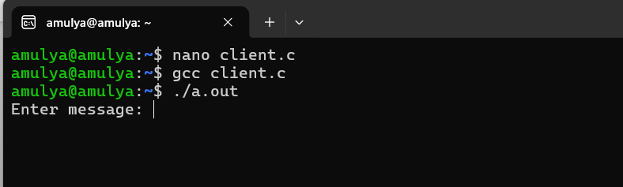
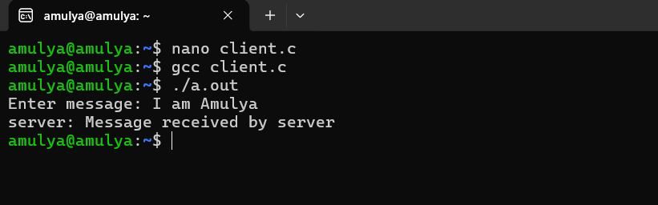

Server:
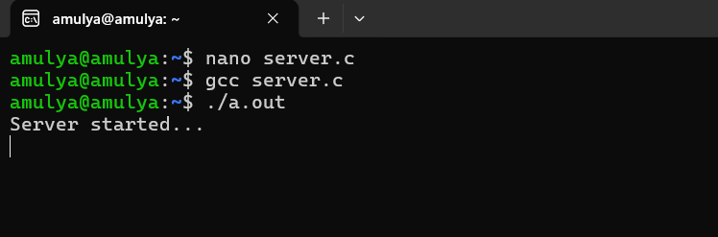
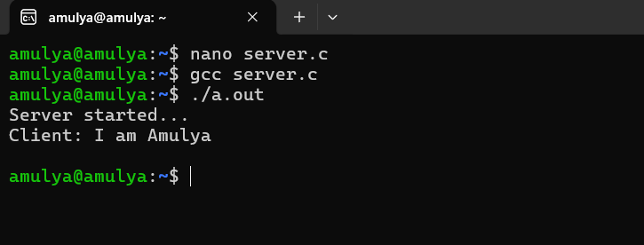

Task-2:
